

# JOINING FORM

|  |
| --- |
| **Declaration** |
| **I have reported for duty at a.m/p.m on (day) (date) at Location.**  **Employee’s Signature Date** |

Internal Use - Confidential

**Payment of Wages (Nomination) Rules, 2009**

# FORM – I

Nomination and Declaration Form (See Rule 3)

1. Name of Person making nomination (in block letters)
2. Father’s/Husband’s name
3. Date of Birth
4. Sex
5. Marital Status
6. Address

Permanent Temporary

I hereby nominate the person(s)/cancel the nomination made by me previously and nominate the person(s) mentioned below to receive any amount due to me from the employer, in the event of my death.

|  |  |  |  |  |  |
| --- | --- | --- | --- | --- | --- |
| Name of Nominee/ nominees | Address | Nominee’s relationship with the member | Date of Birth | Total amount of share of accumulations in credit to be paid to each nominee | If the nominee is a minor, name and address of the guardian who may receive the amount during the minority of the  nominee |
| 1 | 2 | 3 | 4 | 5 | 6 |
|  |  |  |  |  |  |

1. Certified that I have no family and should I acquire a family hereafter, the above nomination shall be deemed as cancelled.
2. *Certified that my father/mother is/are dependent on me.
3. *Strike out whichever is not applicable.

Signature or thumb impression of the employed person

CERTIFIED BY EMPLOYER

Certified that the above declaration and nomination has been signed/thumb impressed before me by Shri./Smt./Kum employed in my establishment after he/she has read the entry/entries have been read over to him/her by me and got confirmed by him/her.

Signature of the employer or other authorised Officer of the establishment and

Designation

Place:

Date:

Name and Address of the Factory/ Establishment and rubber stamp thereof



**Statutory Benefits Nomination Forms:**

**FINAL SETTLEMENT/ GPA/ LIFE INSURANCE COVERAGE NOMINATION FORM**

|  |  |  |  |  |  |  |
| --- | --- | --- | --- | --- | --- | --- |
| -----------hereby nominate the person(s) mentioned bellow to receive the insurance amount payable in the event of my death by accident and direct that the said amount shall be distributed amongthe saidperson(s) in themannershown belowagainst their names: | | | | | | |
|  | **SI.no** | **Name & Address of the Nominee(s)** | | **Relationship** | **Age of** | % **of sharing** |
|  |  | | **With Member** | **Nominee** | **the amount** |
| 1. |  | |  |  |  |
| 2. |
| 3. |
| 4. |
| 5. |
| During the minority of the above named nominee(s), I hereby direct that the person(s) whose particulars are given below shall be deemed to be the guardian of the minor nominee for the purpose of FINAL SETTLEMENT /GPA INSURANCE COVERAGE NOMINATION FORM. | | | | | | |
|  | **SI.no** | **Name of the Nominee** | **Age of** | **Name & Address of** | | **Relationship** |
|  |  | **Minor** | **Guardian** | |  |
| 1. |  |  |  | |  |
| 2. |
| Signed at this day of 20  Signature of Member (Employee)  NOTE:  (1) Where an Employee / Member has a family at the time of appointing a Nominee the Nomination should be made in favor of members of this family only. Any nomination made be such employee in favor of any other person not belonging to his family shall be invalid. (2) An appointment of Nominee made by the Member may be changed at any time after giving a written notice to the Trustees of his intention to do so. If the Nominee predeceases the Member (Employee) or his estate. (Parents, sisters and minor brothers dependent upon him.  (3) The appointment of Nominee or any change thereof made from time to time shall take effect to the extent it is valid on the date or which it is received by the Trustees.(4) For the purpose of the Scheme. "Family" means Member's (Employee's) spouse legitimate children step children, parents, sisters and minor bothers dependent upon him. | | | | | | |

Note: For Dell Records

 **FORM - 2(Revised)**

**EMPLOYEES' PROVIDENT FUND ORGANISATION NOMINATION**

**AND DECLARATION FORM**

**FOR UNEXEMPTED / EXEMPTED ESTABLISHMENTS**

Declaration and Nomination Form under the Employees' Provident Funds and Employees' Pension Scheme.(Paragraph 33 and 61 (1) of the Employees' Provident Fund Scheme, 1952 & Paragraph 13 of the Employees' Pension Scheme, 19951

|  |  |  |  |
| --- | --- | --- | --- |
| 1 | Name (in Block Letters)  Emp lD: |  | Permanent Address |
| 2 | Father's/Husband's Name  (in case of married Women) |  |  |
| 3 | Date of Birth |  |
| 4 | Sex |  | Temporary Address |
| 5 | Marital Status |  |  |
| 6 | Account No |  |

I **PART-A (EPF)** I

I hereby nominate the person(s)/cancel the nomination made by me previously and nominate the person(s), mentioned below to receive the amount standing to my credit in the Employees' Provident Fund, in the event of my death:

|  |  |  |  |  |  |  |
| --- | --- | --- | --- | --- | --- | --- |
| **SI.No.** | Name of the Nominees / Nominees | Address | Nominee's relationshi p  with the Member | Date of Birth | Total amount or share of accumul ation to be paid to each  nominee | If the nominee is a minor, name relationship and address of the guardian who may receive the amount during the minority of nominee |
| **1.**  **2.**  **3.**  **4.**  **5.** |  |  |  |  |  |  |

* 1. *Certified that I have no family as defined in para 1(g) of the Employees' Provident Fund Scheme, 1952 and should I acquire a family hereafter the above nomination should be deemed as cancelled.
  2. *Certified that my father/mother is/are dependent upon me.

Strike out whichever is not applicable. Signature/thumb impression of the subscriber FOR OFFICE USE ONLY

|  |  |  |  |  |  |  |
| --- | --- | --- | --- | --- | --- | --- |
| Dt. of Joinina E.P.F | *I* |  | /20 |  | ENTRIES VERIFIED  D.A s.s A.AO |  |
| Past Service |  | Year |  |
| Date of Joining EPS | *I* |  | /20 |

**Note:** For Department

# I PART- B (EPS) Para 18 !

I hereby furnish below particulars of the members of my family who would be eligible to receive widow/widower/children Pension in event of my death.

|  |  |  |  |  |
| --- | --- | --- | --- | --- |
| SI.  No. | Name of the family member | Address | Date of Birth | Relationship with member |
| 1. |  |  |  |  |
| 2. |  |  |  |
| 3. |  |  |  |
| 4. |  |  |  |
| 5. |  |  |  |

**Certified that I have no family, as defined in para 2(vii) of Employees' Pension Scheme, 1995 and acquire a family hereafter I shall furnish particulars thereon in the above form.

should I

I hereby nominate the following person for receiving the monthly pension (admissible under para 16 (2) (a) (i) and (ii) the event of my death without leaving any eligible family member for receiving pension.

|  |  |  |
| --- | --- | --- |
| Name & Address of the nominee | Date of Birth | Relationship with the member |
| 1.  2. |  |  |

*Strike out whichever is not applicable. Signature /or thumb impression of the subscriber.

I **CERTIFICATE BY EMPLOYER** I

Certified that the above declaration and nomination has been signed / thumb impressed before me by Shri/Smt./Kum ................ .............. ..employed in my establishment after he/she has read the entries/ have been read over to him/her by me and got confirmed by him/her.

Signature of the Employer or other authorized Officers of the Establishment Designation

Date:................

**Note :** For Department

Name & Address of the Factory/Establishment or Rubber Stamp thereof.

Statutory requirement



**FORM-F**

**(See Sub-Rule (1) of Rule 6) NOMINATION**

Emp id : _

* + 1. Shri/smt./Kumari whose particulars are given in the statement below,

hereby nominate the person(s) mentioned below to receive the gratuity payable after my death as also the gratuity standing to my credit in the event of my death before that amount has become payable or having become payable has not been paid and direct that the said amount of gratuity shall be paid in proportion indicated against the name(s) of the nominee(s).

* + 1. I hereby certify that the person(s) mentioned is a/are member(s) of my family within the meaning of clause (h) of Section 2 of the Payment of gratuity Act, 1972.
    2. I hereby declare that I have no family within the meaning of clause (h) of section 2 of the said act.
    3. (a) My father/mother/parents is/are not dependent on me.

(b) My husband's father/mother/parents is/are not dependent on my husband.

* + 1. I have excluded my husband from my family by a notice dated the to the Controlling Authority in terms of the proviso to clause (h) of Section 2 of the said Act.
    2. Nomination made herein invalidates my previous nomination.

|  |  |  |  |
| --- | --- | --- | --- |
| Name in full with full address of nominee(s) | Relationship with the employee | Age of Nominee | Proportion by which the gratuity will be shared |
| **1.** |  |  |  |
| **2.** |  |  |  |
| **3.** |  |  |  |
| **4.** |  |  |  |
| **5.** |  |  |  |

## Statement

* + - 1. Name in full with full
      2. Sex
      3. Religion
      4. Whether unmarried/married/widow/Widower :

**Note:** For Department

* + - 1. Department *I* branch/Section where employed :
      2. Post held with Ticket or Serial No., if any
      3. Date of appointment
      4. Permanent address

Village Thana Sub-division :

Post- office : District State :

Place: Date:

Signature/ Thumb-impression of the employee:

**Declaration by witnesses**

Fresh nomination signed / thumb-impressed before me.

Name in full and full

Address of witnesses Signature of witnesses

1

2

Place:

Date:

**Certificate by the employer**

Certified that the particulars of the above nomination have been verified and recorded in this establishment.

Employer's reference No., if any.

Signature of the employer/ officer Authorized designation

**Authorized Signatory**

Name & Address of the establishment Rubber-stamp thereof

**Acknowledgment by the employee**

Received the duplicate copy of nomination in Form F& Form2 filed by me and duly certified by the employer.

Date: Signature of the employee

**Note:** For Department



**FORM 'Q'**

(See Rule 24 (9A)

**Appointment Order**

1. Name of the Establishment
2. Address of the Establishment
3. Name of the Employee

Empid

1. His / Her Postal Address
2. His / Her Permanent Address
3. Father's/ Husband's Name
4. Date of Birth
5. Date of His / Her entry in to employment
6. Designation
7. Nature of work entrusted to him
8. His / Her serial number in the Register of Employment (Muster Roll)
9. Rates of wages payable to him / her
   1. Basic
   2. VDA
   3. Other Allowances if any (BOA)

TOTAL

Signature of the Employer

Place:

Date :

Acknowledgement by employee

with date and Signature Seal of the establishment



**Declaration by Women employees**

Mis

Dear Madam/ Sir,

I have been apprised of the nature of the business of DELL and my duties and responsibilities. My job may involve working in different shifts including night shift. I am ready and willing to work in different shifts including Night shift as per the requirement of DELL. I understand that DELL will be providing the transport if my work shift ends anytime between 8pm to 6 am.

I understand that if I arrive or leave the office premises at or beyond 8.00 pm I am required to avail the transport facility provided by DELL. I further declare that I understand and have accepted the Dell's policy on safe transport along with the consequence management stated in the policy.

Thanking you,

Signature of the employee

Name of the Employee:

Employee Id

Date

[www.epflndia.gov.in](http://www.epflndia.gov.in/)

Composite Declaration Form -11

(To be retained by the employer for future reference)

**EMPLOYEES' PROVIDENT FUND ORGANISATION**

Employees' Provident Funds Scheme. 1952 (Paragraph 34 **&** 57) **&**

Employees' Pension Scheme, 1995 (Paragraph 24)

**(Declaration by a person taking into employment by any establishment under EPF scheme 1952 and / or EPS 1995 is applicable)**

**)**

**I Name of the member Father'sName**

1. **Spouse's Name**
2. Date **of Birth: ( DD/ MM/ YYYY )**
3. **Gender: (Male/Female/ transgender )**

*s* **Marital Status: (Married/Unmarried/Widow/Widower/Divorcee)**

1. **Email ID:**

**6**

1. **Mobile No.:**

**Present employment details:**

**Date of joining in the current establishment (DD/MM/YYYY)**

**KYC Details: (attach self-attested copies of following KYCs)**

***a)* Bank AccountNo.**

1. ***b)* IFS Code of the branch:**
2. **AADHAR Number**
3. **Permanent Account Number (PAN), if available**
4. **Whether earlier a member of Employees' Provident Fund Scheme,**

**\952**

**Yes/No**

1. **Whether earlier a member of Employees' Pension Scheme, 1995 Yes/No**

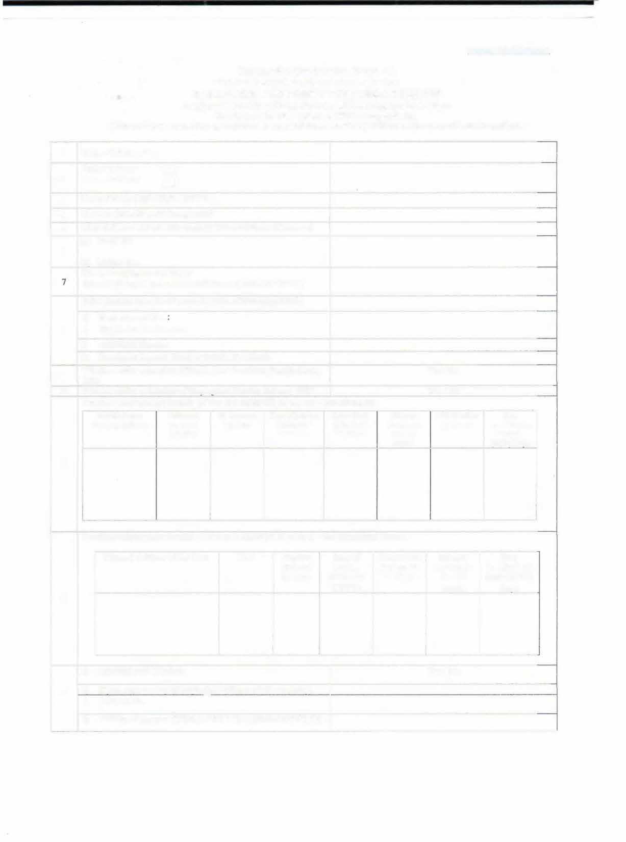

**Previous employment details: [if Yes to 9 AND/OR 10 above)- Exempted**

**Noo Contributory Period**

**{NCP)Davs**

**PPO Number**

Scheme

**Date of exit**

(DD/MM/

***YYYY)***

**Date of joining *(DD/MM/ YYYY)***

**PF Account Number**

**Universal**

**Account Number**

**Establishment**

**Name & Address**

**11**

**Certificate No. (if issued)**

**. (if issued**

**Previous employment details: [If Yes to 9 AND/OR 10 above) - For Exempted Trusts**

|  |  |  |  |  |  |  |
| --- | --- | --- | --- | --- | --- | --- |
| **Name & Address of the Trust** | **UAN** | **Member EPSA/c Number** | **Date of joining (DD/MM/**  **YYYY)** | **Date of exit (DD/MM/ YYYY)** | **Scheme Certificate No. (if issued** | **Non Contributory Period (NCP) Days** |
|  |  |  |  |  |  |  |

12

* 1. **International Worker: Yes/No**

**13 b) If yes, state country of origin(India/Name of other country)**

1. **Passport No.**
2. **Validity of** passport **[(DD/MM/YYYY) to (DD/MM/YYYY)]**

UNDERTAKING

1. Certified that the particulars are true to the best of my knowledge.
2. I Authorize EPFO to use my Aadhar for verification / authentication – KYC purpose for self-delivery
3. Kindly transfer the funds and service details,ifapplicable,from the previous PF a/c as declared above to the present PF account as I **am *an* Aadhar** verified employee in my previous PF Account.•
4. <4) In case of changes in above details, the same will be intimated to employer at the earliest

Date:

Place: Signature of Member

DECLARATION BV PRESENT EMPLOYER

* 1. I member Mr/Ms/Mrs has joined on _·a·nd has been

allotted PF No. **and** UAN

* 1. Incasetheperson wasearliernot I memberof EPFScheme, 1952 and EPS, 1995:

Please Tick the Appropriate Option:

The KYC details of the above member in the UAN database

* + - Have not been uploaded

O Have been uploaded but not approved

* + - Have been uploaded and approved with SDC/e-sign
  1. In casetheperson wasearlier a memberof EPF Scheme, 1952and EPS, 1995:

Please Tack tile Appropriate Option:-

* The KYC details of the above member in the UAN database have been approved with E-sign/ Digital Signature Certificate and transfer request has been generated on portal.
* The previous Account of the member is not Aadhar verified and hence physical transfer form shall be initiated.

Date: S signature of Employer with Sea lof

Establishment

* Auto transfer of previous PF Account would bepossible in respect of Aadhar verified employees only.. Other employee.\ are requested to

file physical claim (Form-l3) for transfer of account from the previous establishment.